PERSPECTIVE 2: LAYERS AND SCOPE (SERVICE MODELS, DEPLOYMENT MODELS)

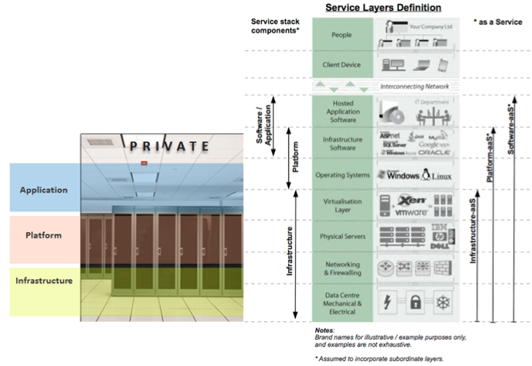

|  |  |
| --- | --- |
| SaaS FROM THE END USERS’ VIEW  Paid Examples:   * •  Salesforce.com * •  Xero * •  Google Apps * •  Apple iCloud  ‘Free’ Examples: * •  TVNZ OnDemand * •  Facebook * •  Gmail * •  Yahoo Mail   Ok, why? You can access the same service anywhere in the world! Isn’t this ideal for individuals and SMEs? |  |
|  |
| PaaS FROM THE END-USERS’ VIEW  Examples:  • Microsoft Azure – Operating System, Database Server, etc.. |  |
|  |

IaaS FROM THE THE END-USERS’ VIEW

Examples from Amazon

• EC2 (Elastic Compute Cloud) - Compute

• S3 (Simple Storage Service) - Storage

Example Clients of IaaS services

• foursquare

• Quora